**The Data:**

Glial cells are important players in synaptic remodeling, metabolic support of neurons, maintaining homeostasis, and response to insult/injury. When insults like infection, trauma, or neurodegeneration occur, glia are quick to respond. Intracellular signaling pathways induce changes in cell morphology and gene expression as reactive glial cells exhibit neuroprotective, phagocytic activity to clear apoptotic cells and degenerating projections. To study conserved glial responses to injury, our lab uses the model organism *Drosophila melanogaster*. Fruit fliesserve as an especially effective model because of extensive genetic tools and the ability to visualize and manipulate discrete populations of cells *in vivo*.

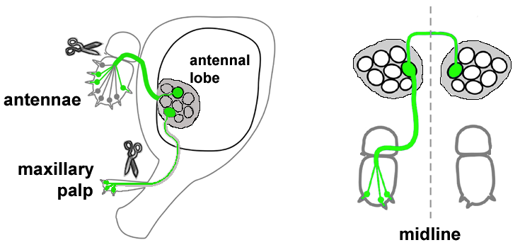My lab uses a few well-established models of *in vivo* axotomy to study glial responses to acute neural injury. One involves using forceps to remove external sensory organs from adult *Drosophila*, severing nerves that project into the antennal lobes of the central brain. These nerves are genetically induced to express GFP, allowing for fluorescent quantification.

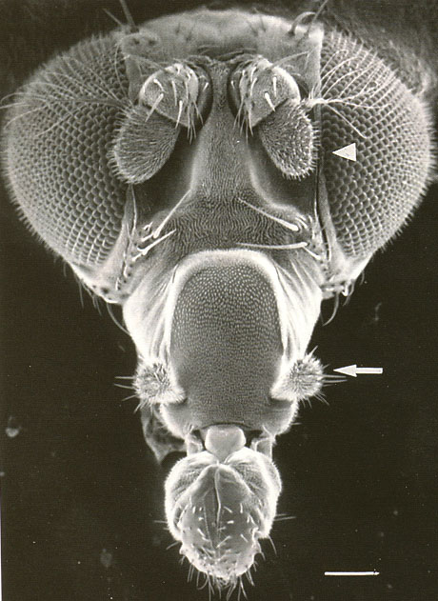

In response to injury, ensheathing glia become reactive, infiltrate the antennal lobe neuropil, and clear the degenerating axonal projections through phagocytic engulfment. Several days after injury, nearly all GFP signal is cleared. This injury protocol is a powerful model for studying the immune function of ensheathing glial cells. The glial immune response is still poorly understood. By manipulating the expression of candidate genes in the context of *in vivo* axotomy, we are able to compare the clearance of degenerating neuronal debris. Variance from control suggests that the given gene has an impact on the ability of glial cells to properly respond to injury.

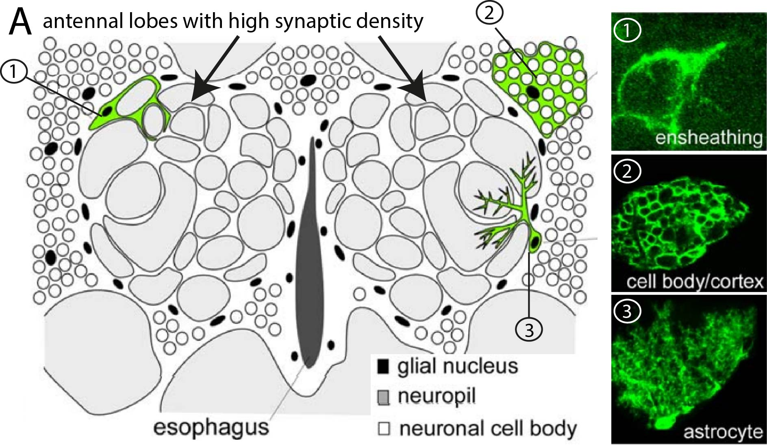

**The Problem:**

NinjurinA (NijA) is an interesting candidate for involvement in glial immunity. NijA is part of a family of nerve injury induced proteins (Ninjurins). Ninjurins are a conserved family of transmembrane receptors found to be upregulated in models of injury, stress, and disease across different species, but specific functions of these proteins are unclear. NijA was upregulated in a nerve injury RNA-seq screen performed by our lab, and our recent unpublished results suggest that glial-derived NijA may be an important player in glial responses to axon degeneration. In this experiment, I functionally assessed the requirement of NijA in the adult CNS. In the experimental condition, I knocked down all glial NijA expression. To assess glial clearance of cellular debris, experiments utilized flies containing a subset of olfactory receptor neurons that are labeled with GFP.

Here's what I have for now! I can get more specific/lead into the exercises with “The Problem” once we decide exactly what path we go down